Visit our website: [www.arch.montana.edu](http://www.arch.montana.edu/)

# The 15th Annual Celebration of Architecture – Thursday, October 24, 2019

**Baxter Hotel Ballroom Willson & Main, Downtown Bozeman, Montana 5:30PM-10:00PM**

**Invitation to the Celebration of Architecture 2019 Sponsored by the School of Architecture, and the Advisory Council**

Thank you for your past support! You are invited to the 15th annual Celebration of Architecture, to be held October 24, 2019.

The Celebration is a “multi-purpose” event to:

* 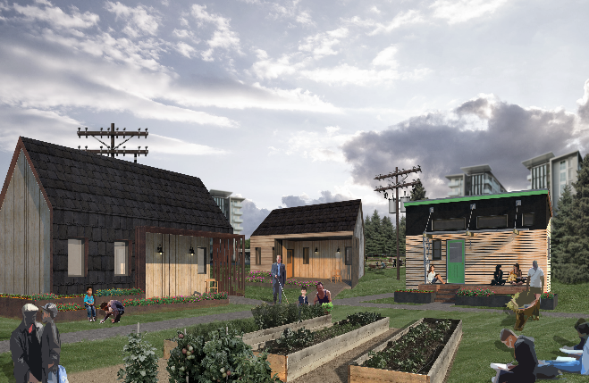CELEBRATE the architecture profession and architecture education,
* RAISE MONEY for the MSU Chapter of American Institute of Architects Students,
* ENRICH the relationship between the profession and education,
* RECRUIT students for internships and permanent positions.

In 2019 the School of Architecture will celebrate the Tiny Houses that the School of Architecture has been working for the past few years. All three photographs show the completed tiny house.

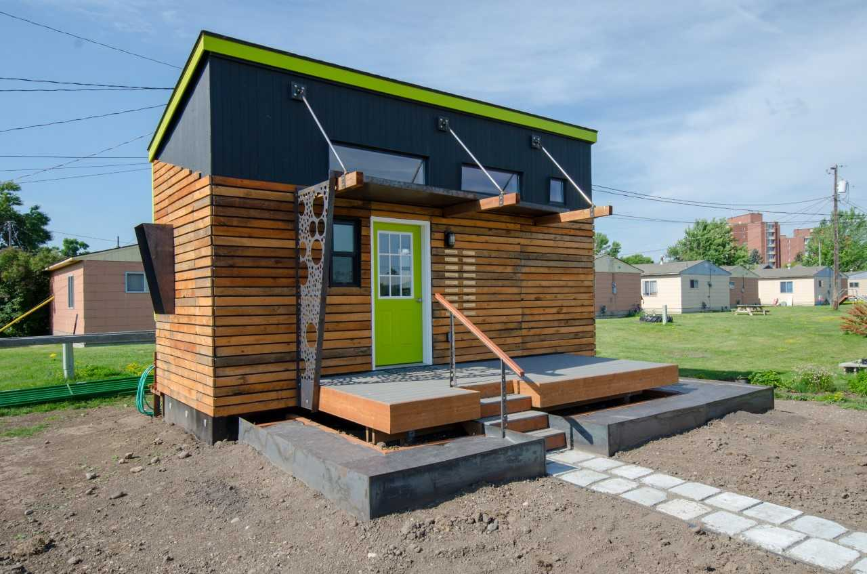

A Six-top Table Sponsorship is $400.00. An Eight-top Table Sponsorship is $500.00. A single plate dinner is $65.00. When your firm sponsors a table, you are seated with 4th & 5th year students, presenting a recruitment opportunity. The School of Architecture can schedule interview times for your firm prior to and after the Celebration of Architecture. We expect 125 attendees---firms, Advisory Council, students, faculty & friends. The dinner will be catered by the Ted’s Montana Grille

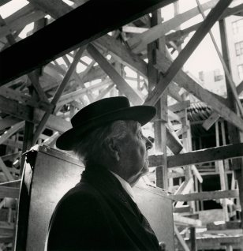

You can also contribute to the event by gifting an auction item. During past events of the Celebration of Architecture, items included original oil paintings, prints, pottery, mixed media, gift baskets, sketches, photos, etc. A wide variety of unique items that make our auctions so interesting! The success of this event will not be possible without you. Our participants make this event very special for the school and its students.

Thank you for your support of the School of Architecture at Montana State University! Your participation will show that we, as a community, support creative arts education and specifically architectural education and architecture as a profession.

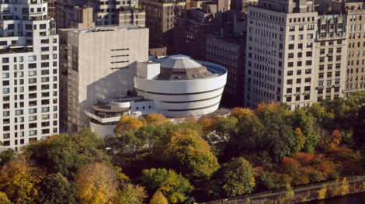If you would like more information regarding the School of Architecture, AIAS, and would like to attend our 15th annual Celebration of Architecture, please call Anne Barnaby at (406) 994- 4255, or email her at [anne.barnaby@montana.edu](mailto:anne.barnaby@montana.edu)

Ralph Johnson Professor & Director

Find us on Facebook: [http://www.facebook.com/pages/Montana-State-University-School-of-](http://www.facebook.com/pages/Montana-State-University-School-of-Architecture/137263362995929?ref=tn)  [Architecture/137263362995929?ref=tn](http://www.facebook.com/pages/Montana-State-University-School-of-Architecture/137263362995929?ref=tn)